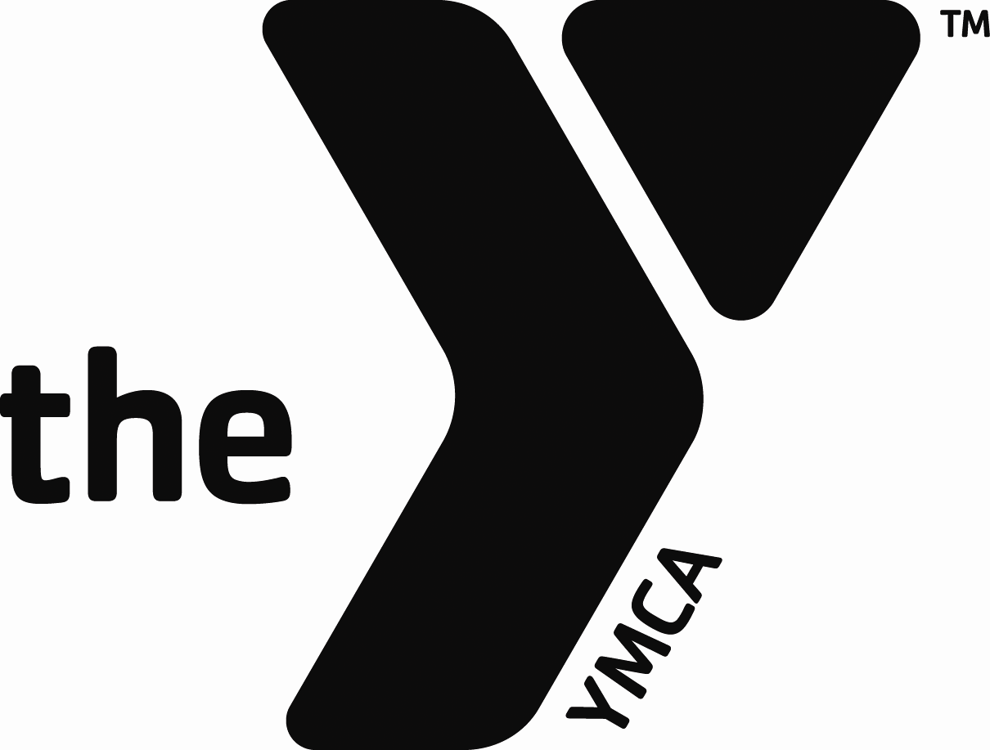

2023 YMCA Corporate Cup
Participant/Special Team Fees
Due: Friday, August 25, 2023

Name of Company ______________________ Division ___________

 | Fee | # of employees/teams | Total
Participant Fee | $8/participant |  | $
Golf | $325/Team |  | $
Bowling | $75/Team |  | $
Kickball | $250/Team |  | $
Softball | $250/Team |  | $
Volleyball | $150/Team |  | $
Awards Ceremony | $50/Company |  | $
Total Due/Paid |  |  | $

